SUPPLIER DATABASE

NAME:VASAVI S PURANIK
USN:1BM24CS320

1.Using Scheme diagram, Create tables by properly specifying the primary keys and the foreign keys

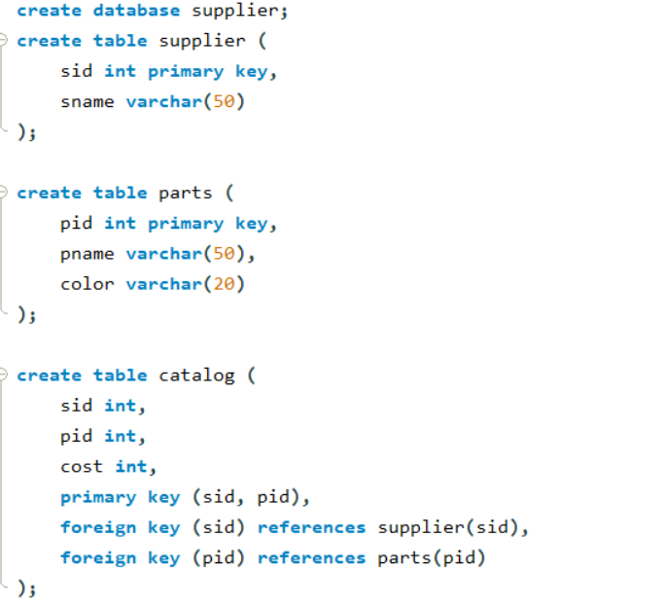

2. Insert appropriate records in each table.
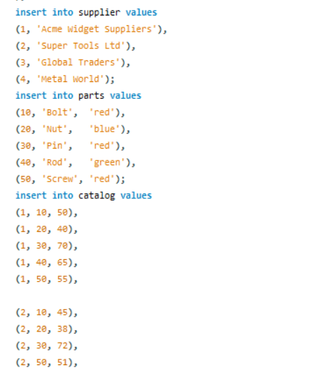
3. Find the pnames of parts for which there is some supplier.
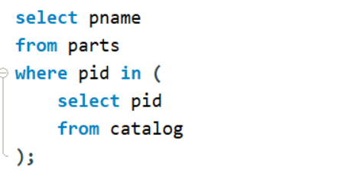
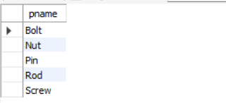

4. Find the snames of suppliers who supply every part.
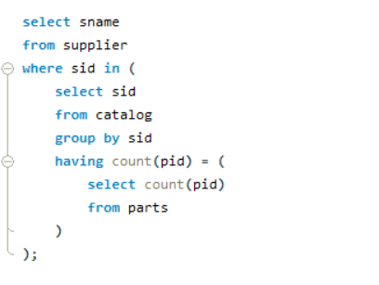
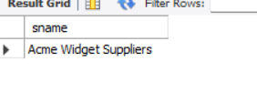
5. Find the snames of suppliers who supply every red part.
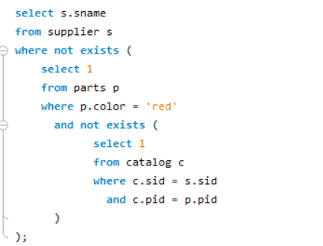
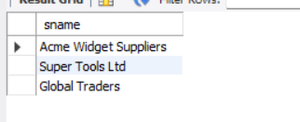
6. Find the pnames of parts supplied by Acme Widget Suppliers and by no one else.
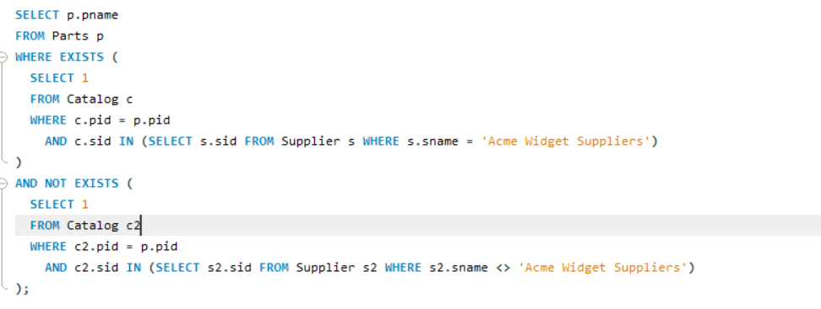
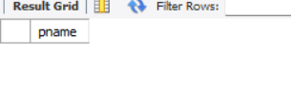
7. Find the sids of suppliers who charge more for some part than the average cost of that part (averaged over all the suppliers who supply that part).
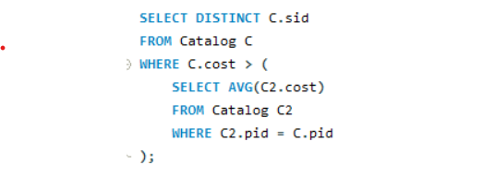
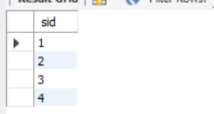

8. For each part, find the sname of the supplier who charges the most for that part.
